**How to use Auto classify XML**

1. In CE Enterprise Manager -> Document Classification Actions -> XML Classifier -> right click “New XML Property Script”.
2. The important classification-related properties of the XML Property Mapping Script class are:

**XML Document Type:**

A string that identifies the document type of the source XML document.

**Target Class:**

The class the XML document is assigned to if automatic classification is successful.

**MIME Type:**

Only support text/xml

1. Sample script:

Create .xslt file with the following code:

<xsl:stylesheet xmlns:xsl="http://www.w3.org/1999/XSL/Transform" version="1.0">

<!-- Output method -->

<xsl:output method="xml" indent="yes"/>

<!-- Match root element -->

<xsl:template match="/">

<Email>

<xsl:apply-templates/>

</Email>

</xsl:template>

<xsl:template match="/Email/Sender">

<From>

<xsl:value-of select="."/>

</From>

</xsl:template>

</xsl:stylesheet>

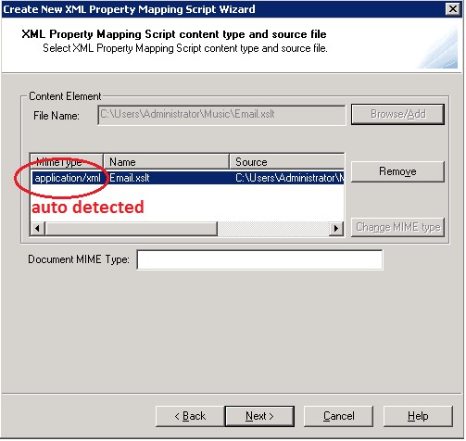

XML Classifier only supports Mime type “text/xml” so you need to change MIME type here

Click again the added content element to enable [Change MIME type] button.

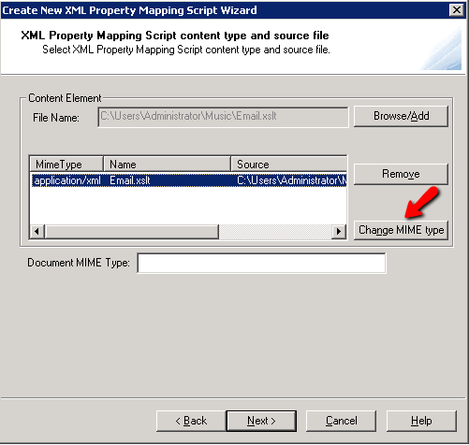

Change MIME type to “text/xml”.

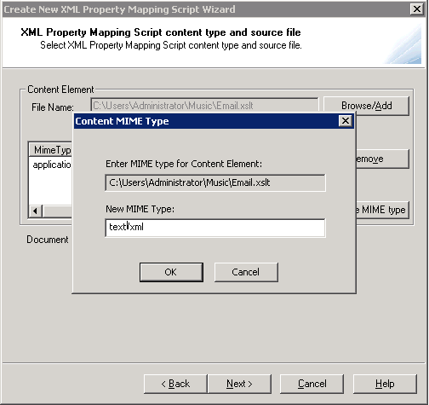

1. With the following configured “XML Property Mapping Script”:

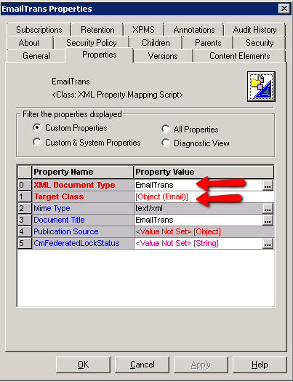

Create .xml to be used as input file:

<?xml version="1.0" encoding="UTF-8"?>

<?FileNetDocClass **EmailTrans**?>

<Email>

<Sender>arafaelle@dalia.com</Sender>

</Email>

1. Config AutoStore:

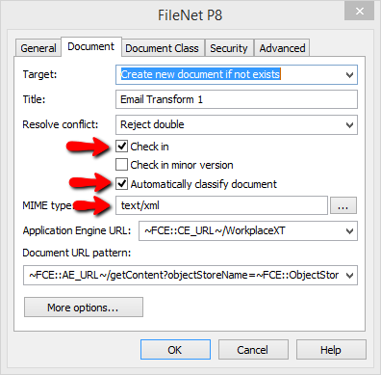

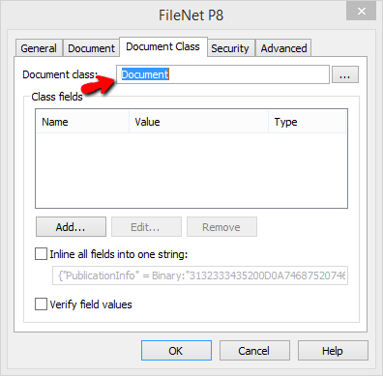

1. Capture and send the xml file created in step 4.
2. Result:

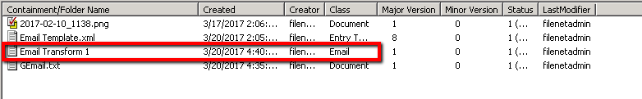

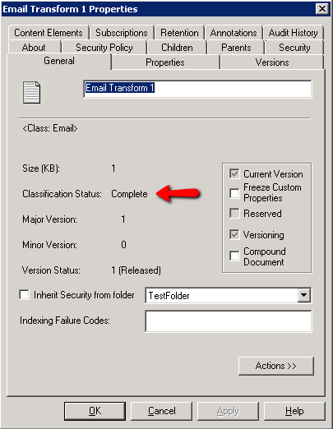

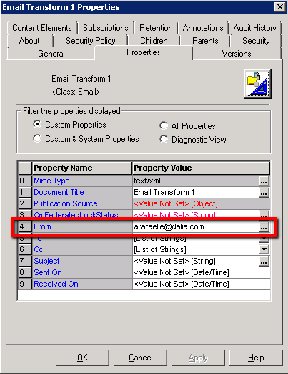

Value in <Sender> tag is auto set to “From” property of “Email” class.

If the Classification Status is “Failed”, check the reason in “p8_server_error.log” file. (Eg file path: C:\Program Files (x86)\IBM\WebSphere\AppServer\profiles\AppSrv01\FileNet\server1)